Visitor Design Pattern
Wednesday, July 1, 2020
10:24 AM

Intent
- 访问者模式是一种将数据操作和数据结构分离的设计模式.

Scenarios
- 对象结构比较稳定，但经常需要在此对象结构上定义新的操作。
- 需要对一个对象结构中的对象进行很多不同的并且不相关的操作，而需要避免这些操作“污染”这些对象的类，也不希望在增加新操作时修改这些类。

Benefits
- 各角色职责分离，符合单一职责原则。
- 具有优秀的扩展性。可以很方便增加其他Visitor.
- 使得数据结构和作用于结构上的操作解耦，使得操作集合可以独立变化.
- 灵活性

Disadvantages
- 具体元素（Credit Cards）对访问者公布细节，违反了迪米特原则。
- 具体元素变更时导致修改成本大。如果CreditCards类中相应数据或结构发生变化，且这些变化会对访问者的操作产生影响，那么许多访问者可能都要因此做出调整。
- 违反了依赖倒置原则，为了达到“区别对待”而依赖了具体类，没来抽象。Visitor会根据CreditCard的不同做不同操作，并不是对CreditCard的抽象类操作，所以存在这个问题。

Single Dispatch and Double Dispatch
- In short, single dispatch is when a method is polymorphic on the type of one parameter (including the implicit this). Double dispatch is polymorphism on two parameters.

There is a problem in inheritance, that is, when you add many functions in the interface and the interface has many child classes. The child classes have to implement the new added functions in themselves. It's pretty trivial. Visitor pattern can resolve this.

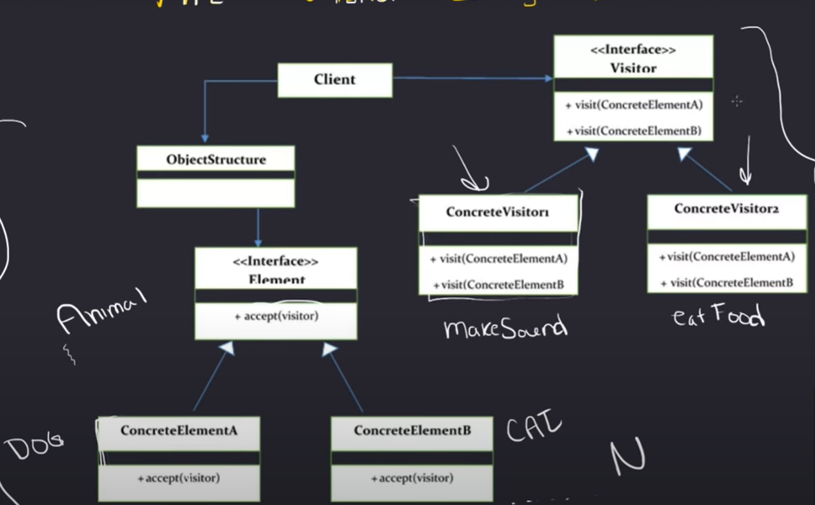

Example
The credit card classes are sort of fixed, but the cash back offers are growing and growing, it could have a huge number kinds of cash back offers. It's unwise to put these operations into credit card classes, cause it will require credit card to modify themselves endlessly.

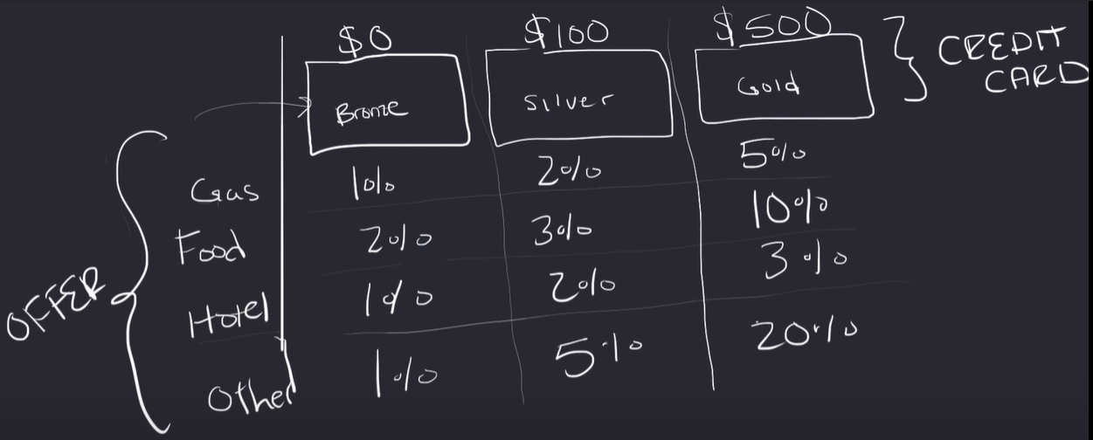

Icredits(Accept(Ivisitor v)) --> BronzeCredit, SilverCredit, GoldCredit
Ivisitor(VisitBronze(BronzeCredit), VisitSilver(SilverCredit), VisitGold(GoldCredit)) --> GasVisitor, HotelVisitor
Icredits credit = new BronzeCredit();
Ivisitor visitor= new GasVisitor;
Credit.Accept(visitor);// In this function visitor will call visitor.VisitBronze(); It's hard code cause Ivisitor contains three functions.

特点
- CreditCards中的类依赖IVisitor,Ivisitor是类中函数的传参。
而继承IVisitor的Visitors类又依赖CreditCards那些类，因为Visitors的Visitxxx函数的参数是这些CreditCards类。
所以这里有个相互依赖的关系。

Add: 将所有变化都放在Visitor里面，而不用去修改Clients，适用于clients相对稳定而政策多变的情况
例：
- Café Visitor, which contains various discount policies for different credit card users
- Right now, we have a Silver Card user, so we create a Silver Card user
- When Silver Card user do something like check out, it will call CheckOut(Ivisitor xxx); and in the function visitor will call specific function according to the user type(this). Different users will do the same thing with different functions(With different discount).

